NWAVE BASE STATION USER MANUAL

Table of Contents
1. Base station connectors description 2
2. Base station setup 2
2. 1. Connect Ethernet cable to the network connector (an internet connection is needed), as it is shown at the pictures below 3
2. 2. Connect Dongle device to the USB connector, as it is shown at the pictures below 3
2. 3. Connect Development Kit board to the USB connector, as it is shown at the picture below 3
2. 4. Connect Power Supply adapter to the Power connector 4
2. 5. Press Power Button at the top of the base station case 4
3. Revision History 5

1. Base station connectors description

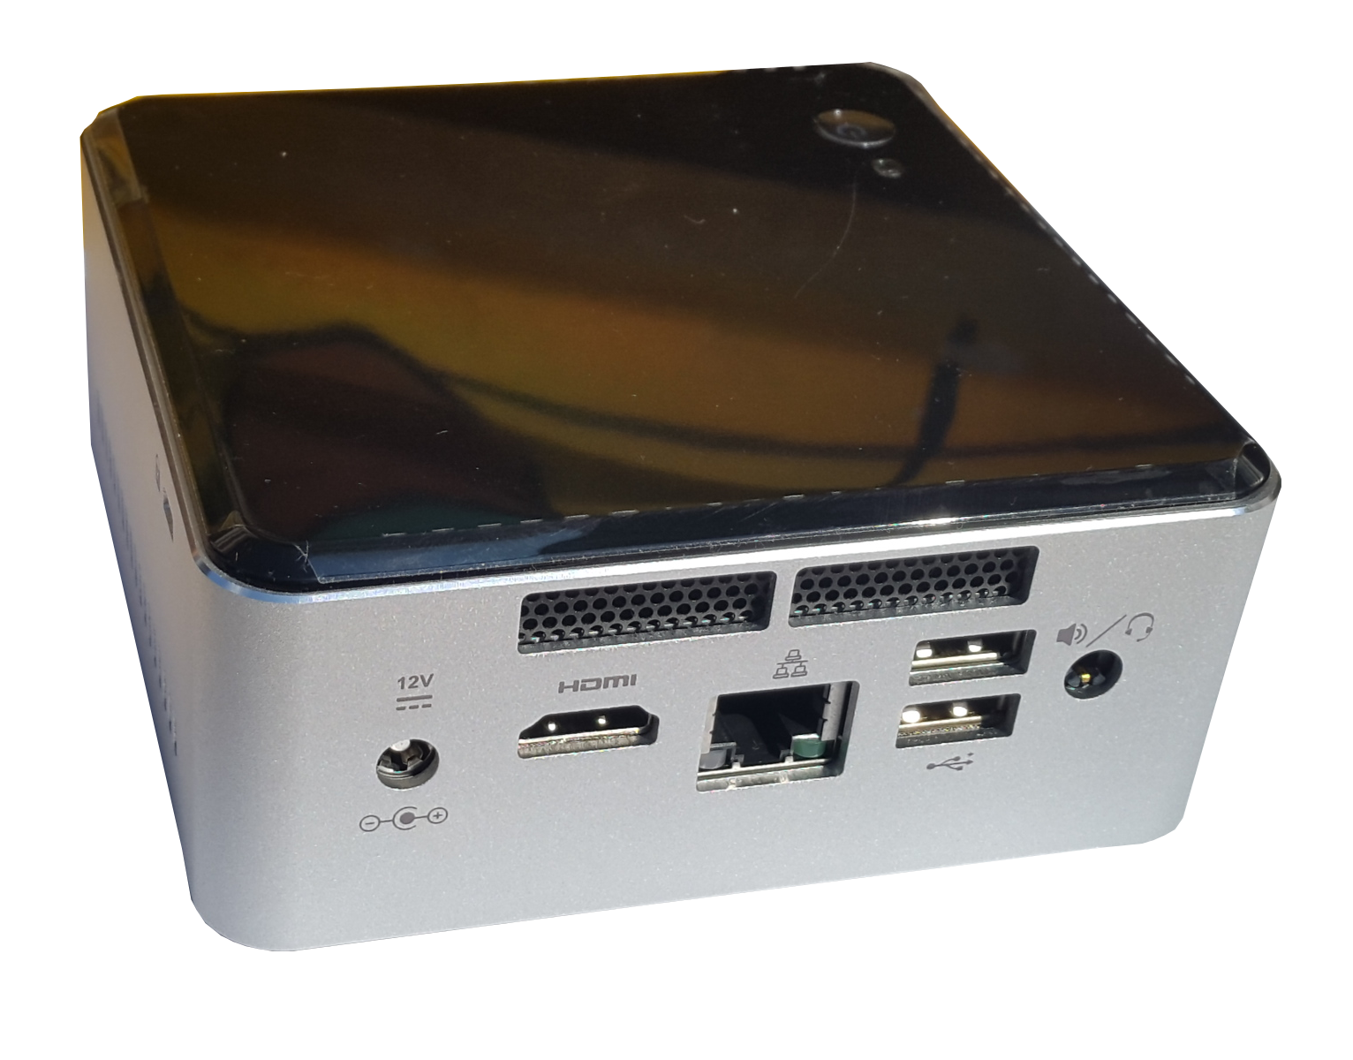
Power
Video
Network
USB
Audio

2. Base station setup
A base station comes with installed and prepared software which is ready to start. User has to complete installation steps described below.

2. 1. Connect Ethernet cable to the network connector (an internet connection is needed), as it is shown at the pictures below

2. 2. Connect Dongle device to the USB connector, as it is shown at the pictures below

2. 3. Connect Development Kit board to the USB connector, as it is shown at the picture below

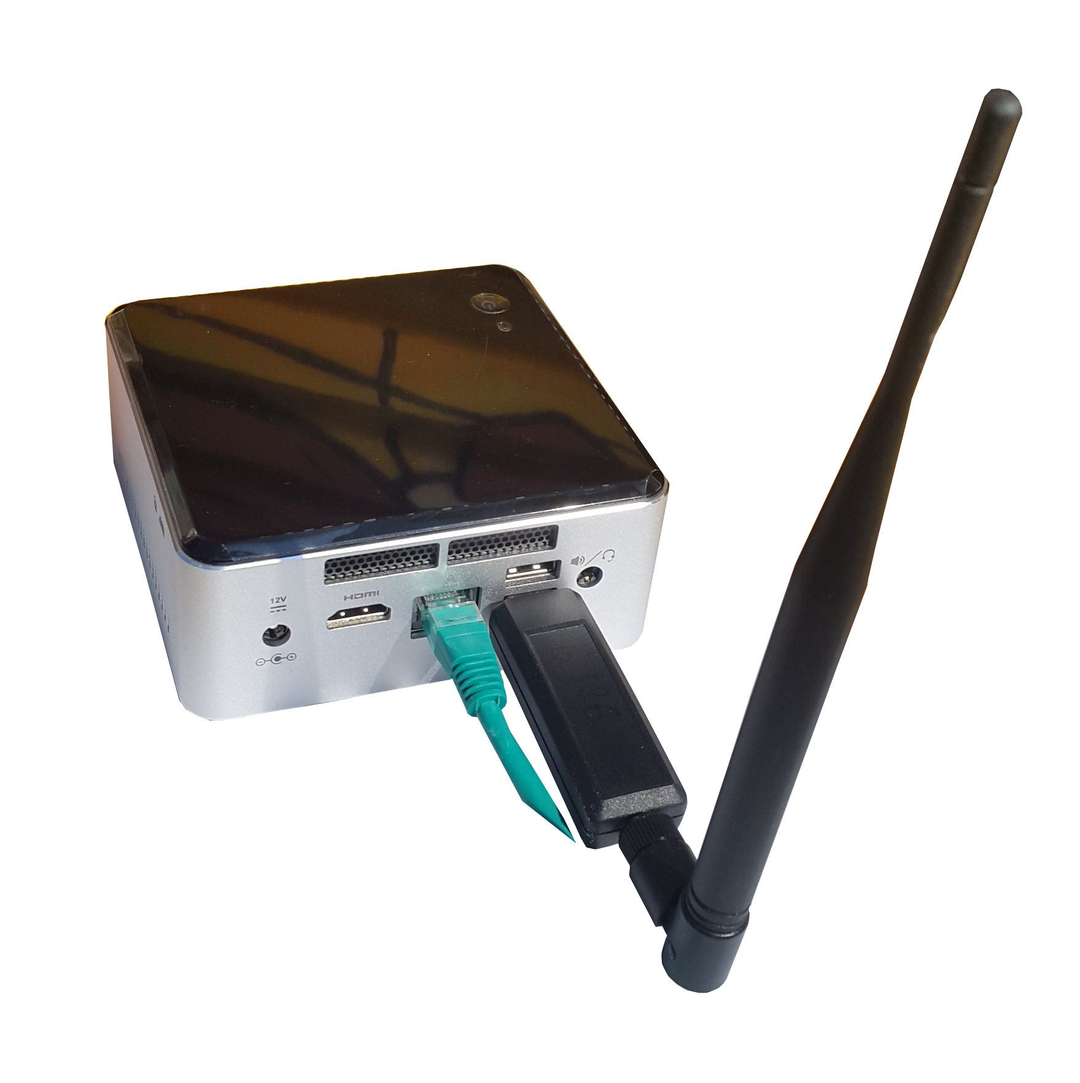

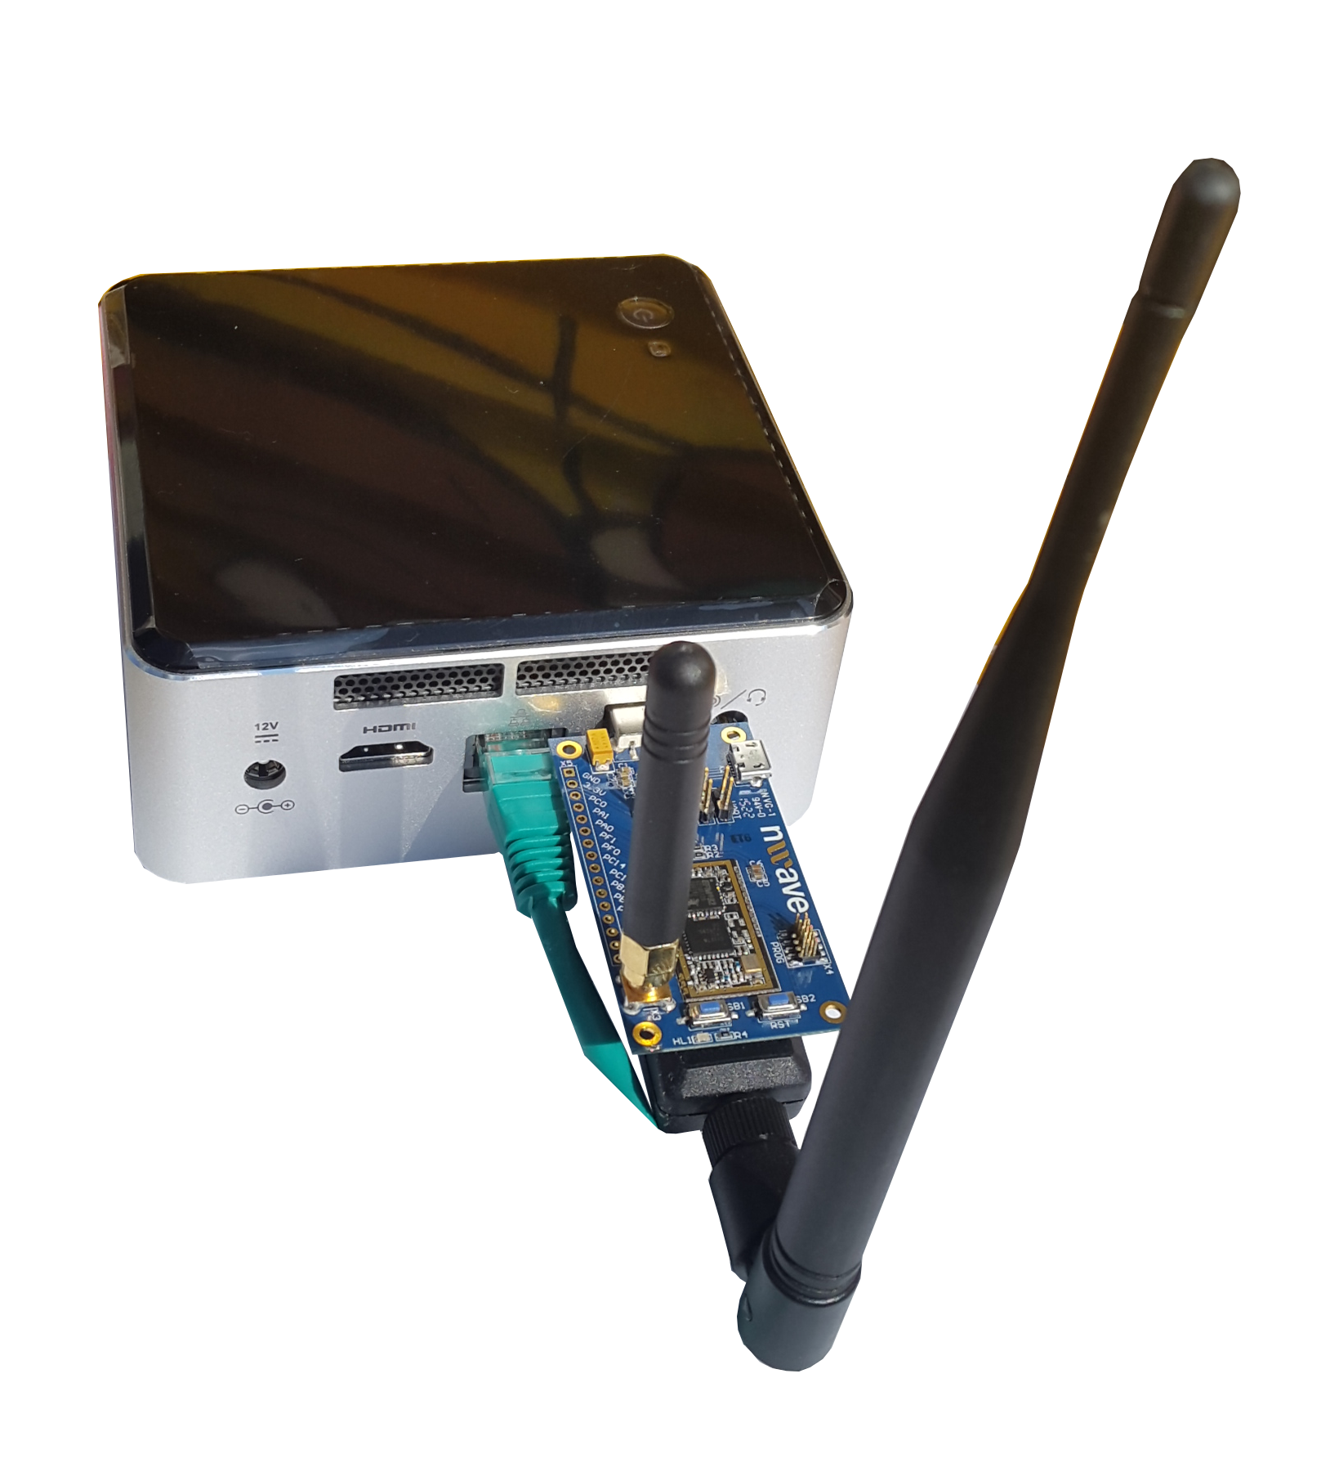

2. 4. Connect Power Supply adapter to the Power connector

2. 5. Press Power Button at the top of the base station case

3. Revision History
Here is a revision history for this document.
Author | Description of Changes | Date | Revision Number
Ruslan Gerasimov | Created | 01-07-2015 | 1.1

